

Name: Muhammad Zohaib khan

Reg# BSE203003
Subject: DS LAB 2
Section#1
Date:1 -11-2021

Practice Task 2:
#include<iostream>
#include<string>
using namespace std;
class book
{
string name;
string author;
int price;

public:
void set()
{
cout << "Enter name of the book";
cin >> name;
cout << "Enter author name of the book";
cin >> author;
cout << "Enter price of the book";
cin >> price;

}

void display()
{
cout << "Name of the book is " << name << endl;
cout << "Author name of the book is " << author << endl;
cout << "Price of the book is " << price << endl;

}

};
class list
{
int maxsize = 10;
int size = 0;
book *book_id;
public:

void create_list(int size)
{
book_id = new book[size];
}
bool isEmpty()
{
if (size == 0)
{
return true;
}
else
{
return false;
}
}
bool isFull()
{
if (size == maxsize)
{
return true;
}
else {
return false;
}
}
void insert()
{
if (!isFull())
{
book_id[size].set();
size++;
}
else { cout << "list is full" << endl; }
}
void spc_insert(int pos)
{
if (pos <= size)
{
for (int i = size; i > pos - 1; i--)
{
book_id[i + 1] = book_id[i];
}
book_id[pos].set();
}
size++;
}

bool spc_Delete(int pos)
{
if (pos >= 0 && pos <= size)
{
for (int i = pos; i < size; i++)
{
book_id[i] = book_id[i + 1];
}
size--;
return true;
}
return false;
}
void seq_delete()
{
if (!isEmpty())
{
for (int i = size; i >= 0; i--)
{
size--;
}
}
}
int getlength()
{
cout << "size of the array list is " << size << endl;
return size;
}
void showall()
{
for (int i = 0; i < size; i++)
{
cout << "Data of book " << i << " is:" << endl;
book_id[i].display();

}
}

};
int main()
{
list obj;
int opt;
cout << "Press 1 to sequential insert data in list " << endl;
cout << "Press 2 to sequential delete in list " << endl;
cout << "Press 3 to specfic insert" << endl;
cout << "Press 4 specfic delete" << endl;
cout << "Press 5 display all data in the list" << endl;
cout << "Press 6 show length of the list" << endl;
cin >> opt;
switch (opt)
{
case 1:
obj.insert();
break;
case 2:
obj.seq_delete();
break;
case 3:
int pos;
cout << "Enter book id";
cin >> pos;
obj.spc_insert(pos);
break;
case 4:
int id;
cout << "Enter book id";
cin >> id;
obj.spc_Delete(id);
break;
case 5:
obj.showall();
break;
case 6:
obj.getlength();
break;
}

}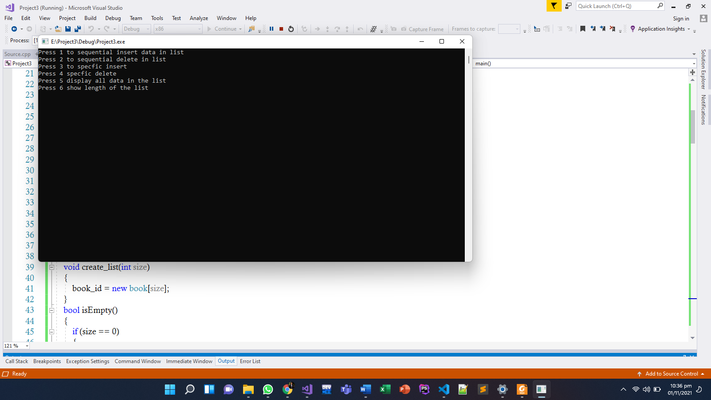

Practice Task 3:

#include <iostream>
#include<string>
using namespace std;
class Employee
{
string Name;
int Emp_No;
int Experience;
string Designation;
int Salary;
public:
void setname(string na)
{
Name = na;
}
void setempno(int no)
{
Emp_No = no;
}
void setexp(int ex)
{
Experience = ex;
}
void setdesignation(string des)
{
Designation = des;
}
void setsalary(int sal)
{
Salary = sal;
}
string getname()
{
return Name;
}
int getempno()
{
return Emp_No;
}
int getexperience()
{
return Experience;
}
string getdesignation()
{
return Designation;
}
int getsalary()
{
return Salary;
}
void Display()
{
cout << "Employee Name: " << Name << endl;
cout << "Employee ID: " << Emp_No << endl;
cout << "Employee Experience: " << Experience << endl;
cout << "Employee Designation: " << Designation << endl;
cout << "Employee Salary: " << Salary << endl;
}
void Input()
{
cout << "Enter Employee Name: ";
getline(cin, Name);
cin.ignore();
cout << "Enter Employee ID: ";
cin >> Emp_No;
cout << "Enter Employee Experience: ";
cin >> Experience;
cout << "Enter Employee Designation: ";
getline(cin, Designation);
cout << "Enter Employee Salary: ";
cin >> Salary;
}
};
class list
{
Employee *Elements;
int size;
int top;
string temp;
public:
list(int maxsize)
{
size = maxsize;
top = 0;
Elements = new Employee[size];
}
void Insert(Employee Obj)
{
if (Obj.getexperience() == 2)
{
Elements[top] = Obj;
top++;
}
else
{
cout << "Insert: List is Full!! \n";
}
}
bool isEmpty()
{
if (top == -1)
return true;
else
return false;
}
bool isFull()
{
if (top == size)
return true;
else
return false;
}
void Show(Employee Obj)
{
if(!isEmpty())
{
for (int i = 0; i < top; i++)
{
if (Obj.getsalary() == 50000)
{
Elements->Display();
}
}
}
else
{
cout << "list is Empty!!! ";
}
}
void Order()
{
for (int i = 0; i < size; i++)
{
for (int j = 0; j < size - i - 1; j++)
{
if (Elements[j].getname() > Elements[j + 1].getname())
{
temp = Elements[j + 1].getname();
Elements[j + 1] = Elements[j];
Elements[j].getname() = temp;
}
}
}
for (int i = 0; i < size; i++)
{
Elements[i].Display();
}
}
};
void main()
{
int sta;
cout << "Enter the size of list: ";
cin >> sta;
Employee emp;
int option;
char ch;
list s1(sta);
do
{
cout << "\n-------------------------" << endl;
cout << " M E N U " << endl;
cout << " 1. Insert " << endl;
cout << " 2. Display " << endl;
cout << " 3. Display Alphabteical " << endl;
cin >> option;
switch (option)
{
case 1:
s1.Insert(emp);
break;
case 2:
s1.Show(emp);
break;
case 3:
s1.Order();
break;
default:
cout << "INVALID INPUT!!!!!" << endl;
}
cout << "WANT TO INPUT AGAIN!!! (Y/y): ";
cin >> ch;
} while (ch == 'y' || ch == 'Y');
system("pause");
}
